Figure 5.5 Initial version of the DevOps Adoption Driver

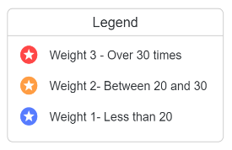

**­­**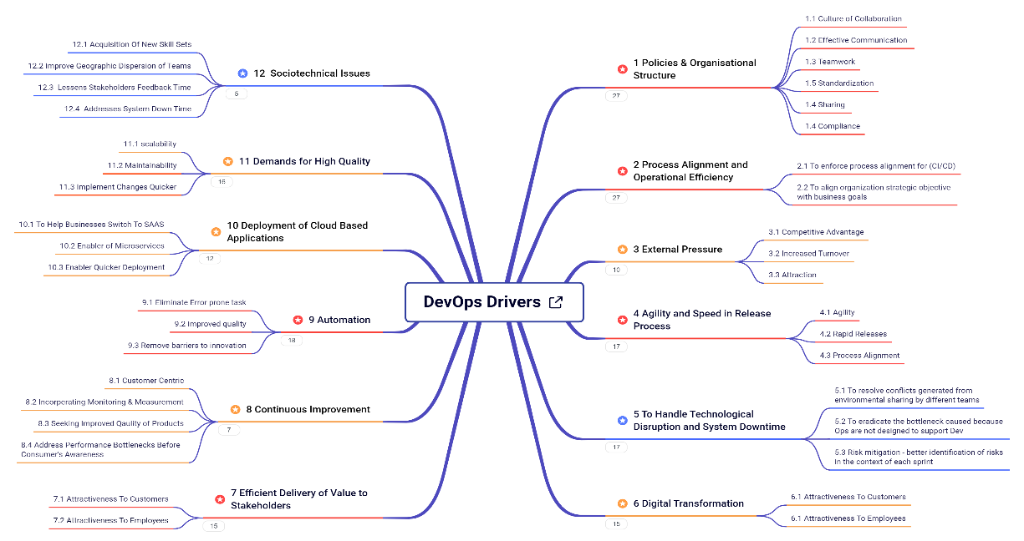

Figure 5.6 ­­­­ The updated version of the DevOps Adoption Driver

